LAPTOP PRICE PREDICTION USING ML ALGORITHMS



A Minor Project Report

in partial fulfillment of the degree

Bachelor of Technology
in
Computer Science & Artificial Intelligence

By

2103A52065 P.Bhavana
2103A52063 H.Dharani
2103A52156 V.Shivani

Under the Guidance of

Dr.K.Rajchandar Sir Assistant. Prof, CS&AI Department

Submitted to




SCHOOL OF COMPUTER SCIENCE & ARTIFICIAL INTELLIGENCE

SR UNIVERSITY, ANANTHASAGAR, WARANGAL
April, 2024.

SCHOOL OF COMPUTER SCIENCE & ARTIFICIAL INTELLIGENCE

CERTIFICATE

This is to certify that this project entitled “LAPTOP PRICE PREDICTION USING ML ALGORITHMS” is the bonafied work carried out by P.Bhavana, H.Dharani, V.Shivani as a Minor Project for the partial fulfillment to award the degree BACHELOR OF TECHNOLOGY in COMPUTER SCIENCE & ARTIFICIAL INTELLIGENCE during the academic year 2023-2024 under our guidance and Supervision.

Dr.K.Rajchandar Dr. M.Sheshikala
Assistant. Prof, CS&AI Department, Assoc. Prof. & HOD (CSE),
SR University, SR University,
Ananthasagar, Warangal. Ananthasagar, Warangal.

External Examiner

ACKNOWLEDGEMEN

We owe an enormous debt of gratitude to our project guide Dr. K.Rajchandar , Assistant Professor as well as Head of the CSE Department Dr. M.Sheshikala, Associate Professor for guiding us from the beginning through the end of the Minor Project with their intellectual advices and insightful suggestions. We truly value their consistent feedback on our progress, which was always constructive` and encouraging and ultimately drove us to the right direction.

We express our thanks to project co-ordinators Dr. P Praveen, Assoc. Prof for their encouragement and support.
We wish to take this opportunity to express our sincere gratitude and deep sense of respect to our beloved Dean, Dr.C.V.Guru Rao, for his continuous support and guidance to complete this project in the institute.

Finally, we express our thanks to all the teaching and non-teaching staff of the department for their suggestions and timely support.

P.Bhavana
H.Dharani
V.Shivani

iii

iv
ABSTRACT
Laptop is One of the most important and widely used electronic gadgets in our daily lives for a variety of tasks is the laptop. There are several specs and brand names available on the market, making it challenging for both laptop manufacturers and consumers to choose one. In order to get started, we gather a large dataset of laptops with information on their brand, processor type, RAM size, storage capacity, graphics card, display size, and other characteristics. We train and test our prediction models using this dataset. We then handle missing values, encode categorical variables, and normalise numerical features as part of the preprocessing of the data.

we propose a novel method that aims at finding significant features by applying machine learning models
resulting in improving the accuracy in the prediction of laptop price. The prediction model is introduced with
different combinations of features and several known machine learning models. We are using three different
machine learning models Decision tree, Multiple linear regression, Random forest, and KNN to check which
machine learning model is more accurate in predicting the price of the laptop.
CONTENT
v
V
6.

RESULTS
20

7.

8.

9.

CONCLUSION

FUTURE SCOPE

BIBILOGRAPHY

21

23

Chapter No.
Title
Page No.

1.
INTRODUCTION
01

1.1 Existing System
03
1.2 Proposed System
03
1.3 Objectives &
Beneficiaries
03
2.
LITERATURE SURVEY

04
2.1 Related work
06
2.2 System Study
07
3.
DESIGN
08
3.1 Requirements
specifications
08
3.2 UML Diagram
09

3.3 Flow Chart
10
4.
IMPLEMENTATION
11
4.1 Modules
11
4.2 Data Set
11
4.3 Overview Technology
13
5.
TESTING
18
5.1 Test Cases
18
5.2 Test Results
19
`
1
1.
INTRODUCTION
A laptop is a tiny, portable computer having a screen and a keyboard with a large number of keys.
Although 2-in-1 PCs with a detachable keyboard are commonly marketed as laptops or as having a laptop
mode, they typically have a clamshell form factor, with the screen attached on the inside of the upper lid and
the keyboard mounted on the inside of the lower lid. Laptops are suited for mobile use because they can be
folded shut for traveling. Its name originates from the fact that it was deemed practical to use while sitting on
a person's lap. Laptops are now utilized in a wide range of situations, including at work, in schools, for gaming,
web browsing, personal multimedia, and general home computer use.
Laptops combine all of the input/output components and capabilities of a desktop computer into a
single unit, including the display screen, small speakers, keyboard, data storage device, optical disc drive,
pointing devices (such as a touchpad or a pointing stick), operating system, processor, and memory. Most
current laptops include built-in webcams and microphones, and many also include touchscreens. Laptops can be
powered by an internal battery or an external power source such as an AC adapter. Hardware parameters, such
as CPU speed and memory capacity, vary greatly across types, models, and price ranges.
The importance of laptops in our daily lives cannot be overstated. Humans evaluate and challenge
science daily in everyday life. Laptops, like desktop computers, are ubiquitous in our daily lives. Raw data is
transformed into valuable and meaningful knowledge in all of these contexts: companies, businesses, banks,
schools, universities, and homes. Engineers, doctors, students, teachers, business people, and government
agencies all use it for specific duties, amusement, internet earnings, and office work. Laptops are a blessing
for people if they are used for good causes.
The majority of businesses keep all of their operational and accounting data on a laptop. Today, a degree of
global business operations without the use of computer technologies and the internet is unthinkable. Laptops
make it simple to store and retain data, as well as locate files and important information. Spreadsheets,
accounting and administrative systems, transaction processing, and traceability systems are just a few examples
of tools and software that make administrative work easier and more productive. The company’s laptops can
compute and summarise data entered in reports, statements, and papers that are utilized for a variety of
purposes. Databases are maintained on laptops by businesses of all sizes. Databases are computer programs
that store and manage important data, such as client contact information.
Machine learning is a branch of Artificial intelligence that deals with implementing applications that can make
future predictions based on past data. If you are a data science enthusiast or a practitioner then this article will
help build your own end-to-end machine learning project from scratch.
2
There are various steps involved in building a machine learning project but not all the steps are mandatory to
use in a single project, and it all depends on the data. In this article, we will build a Laptop price prediction
project and learn about the machine learning project lifecycle. In machine learning, a multiple regression
model is a supervised learning strategy for approximating the mapping function to obtain the best predictions.
Regression's major purpose is to build an efficient model that can predict the dependent attribute from a set of
attribute variables. When the output value is actual or continuous, such as price, it is referred to as a
regression problem.
Random forest is a supervised machine learning algorithm that is commonly used to solve classification and
regression problems. It creates decision trees from various samples, using the majority vote for classification
and the average for regression. One of the most essential characteristics of the Random Forest Algorithm is
that it can handle data sets with both continuous and categorical variables, as in regression and classification.
For classification difficulties, it produces superior results.
A decision tree is the most powerful and popular tool for categorization and prediction. A decision tree is a
flowchart-like tree structure in which each internal node represents an attribute test, each branch reflects the
test's conclusion, and each leaf node (terminal node) stores a class label.
We will make a project for Laptop price prediction. The problem statement is that if a user wishes to buy a
laptop, our application should be able to deliver a rough price for a laptop based on the user's preferences.
Although it appears to be an easy project or simply constructing a model, the dataset we have is noisy and
requires extensive feature engineering and preprocessing, which will pique your interest in working on it.
3
1.1
EXISTING SYSTEM
There are some proposed models to predict the laptop price - One is to find the price of a laptop
through the c4.5 algorithm and the prediction of student interest in the laptop specifications through the
application of data mining using the C4.5 algorithm. The method used in this research is a survey method
by conducting the interview. This research was conducted by conducting interviews with several students.
The result of this was a decision tree that describes the laptop specifications that are most in-demand by
students, so students who want to have a laptop can easily determine laptop specifications based on the
number of enthusiasts on certain laptop specifications. The technique used in the application of data mining
in this research is a classification technique. The conclusion of this research is that by implementing data
mining, students don’t need to look for various sources to find laptop specifications that are needed by
students in meeting their college needs for a long time.
1.2
PROPOSED SYSTEM
The existing model predicts the price for fewer specifications and does not accurately. The
proposed system ensures more specifications and accurate prices. This project aims that if a user wishes to
buy a laptop, our application should be able to deliver a rough price for a laptop based on the user's
preferences. Although it appears to be an easy project or simply constructing a model, the dataset we have
is noisy and requires extensive feature engineering and preprocessing, which will pique your interest in
working on it.
The machine learning model that we are working on it is a Laptop price predictor. we create a
website where a machine learning model runs behind. The work of that machine learning model is that if
the user tells its desired configuration then our model will predict the price of the laptop according to the
given configurations.
1.
3 OBJECTIVES & BENEFICIARIES
The main objective of this project is to predict the price of the laptop just by choosing the desired
configurations instead of searching them all online.
It’s easy and simple to use. comparison of laptop prices with changes in configurations becomes easy.
4
2.
LITERATURE SURVEY
Machine learning is helpful for a variety of situations. The prediction of dependent variable
values from independent variables is one of the uses of this methodology. The field of laptop price prediction
is a data mining field since it contains extensive data resources that are challenging to manually handle. We
will have data and with the help of the data inputs that we have, we predict the price of the laptop. Machine
learning methods can nonetheless be helpful in solving this challenge and in anticipating danger early. Some
of the techniques used for such prediction problems are multiple linear regression, decision tree, and random
forest algorithms.
The existing research has less input. We predict the price by taking a few more configurations and
we used different methods to improve the accuracy in the prediction of laptops but they are not much more
accurate than our proposed system with the comparison accuracy rates when compared to an existing system
to the proposed system. In the proposed system our model showed accuracy rates with the highest accuracy
rate with Random Forest.
In "Classification Based on Decision Tree Algorithm for Machine Learning" Behzad Tahaz
Jijo1*, Adnan Mohsina Abdulazeez2 proposed the basic goal of the Decision tree algorithm, Decision tree
algorithm, which belongs to the supervised getting to know algorithm family, is building a coaching model
that can be used to predict the class or cost of goal variables by using inferring decision policies from coaching
data. Regression and classification problems can each be solved with the use of the Decision Tree technique.
The Decision Tree is ordinarily used for grouping purposes. Furthermore, the Decision Tree is a common
categorization model in Data Mining. Each tree is made up of nodes and branches. Each subset defines a
price that the node can take, and each node represents facets in a category to be categorized. Decision trees
offer a wide variety of functions due to their easy analysis and precision across many statistics types. Decision
tree nodes are frequent for presenting a extra entire photo of overall performance results. All recognized
statistics classifiers use optimized splitting parameters and are upgraded.
In the paper "Popular Decision Tree Algorithm of Data Mining Techniques" Radwan Abbas F.
H. Alhaurin, Ali S. A. Al-Haboob were discussed the selection tree Depending on the quantity of data, the
effectiveness of the method, and the amount of memory available, the Decision Tree classification algorithm
can be performed in serial or parallel phases. A serial tree is a logical model that is constructed with the use
of a coaching information set and is represented as a binary tree. Using predictor variables, aids in the
prediction of the cost of a goal variable. As illustrated in Fig. 1, selection timber makes it simpler to signify
data and generate IF-ELSE categorization rules.
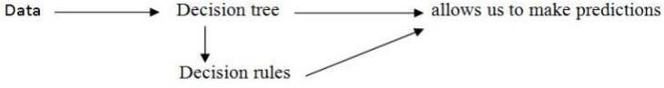
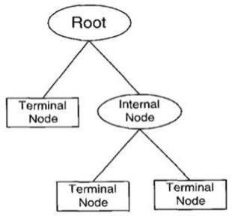
5
Fig1 Decision rules
It is made up of hierarchically arranged rules. It's a simple recursive shape for presenting a judgment method
in which a future instance is labeled into contemporary distinct classes and observations are divided into
jointly different subgroups. Each department of the tree represents one or greater data from the original
records collection. The root node (no inbound link) is at the pinnacle of the tree and represents all of the rows
in the dataset. The internal or choice nodes (with solely one incoming link) are used to take a look at an
attribute. The down most nodes are named as terminal nodes (no out coming link) and denote a decision class,
as shown in Fig2
Fig 2 Decision tree
The University of California, Berkeley, CA 94720 published a paper Growing a group of trees and allow
them to vote for the most famous type resulted in significant increases in classification accuracy. Random
vectors that regulate the increase of every tree in the ensemble are frequently built to grow these ensembles.
Bagging (Breiman, 1996) is an early example, in which a random choice (without replacement) is selected
from the instances in the education set to develop each tree. They outline a huge wide variety of geometric
facets and search thru a random decision of them for the fantastic break up at every node in an important
paper on written personality recognition. This remaining paper has affected my thinking. In all of these
techniques, a random vector okay is created for the kth tree, unbiased of the previous random vectors 1,...,k1,
however with the equal distribution; then a tree has shaped the usage of the coaching set and k, resulting in a
classifier h(x, k), where x is an enter vector. For example, in bagging, the random vector is generated by
counting the variety of darts thrown at random into N boxes, the place N is several examples in the training
set. Several independent random integers between 1 and K are used in random split selection. Its dimensions
6
and character are determined via its software in tree construction. They vote for the most popular category as
soon as a huge variety of timber has been created. These strategies are regarded as random forests.
2.1
RELATED WORK
Predicting the price of laptops has been studied extensively in various researches. that
regression model that was built using Decision Tree & Random Forest Regressor can predict the price of a
laptop that has been leased with better precision than multivariate regression or some simple multiple
regression. This is because the Decision Tree Algorithm is better at dealing with datasets with more
dimensions and it is less prone to overfitting and underfitting. The weakness of this research is that a change
of simple regression with a more advanced Decision Tree Algorithm regression was not shown in Basic
indicators like mean, variance, or standard deviation.
Machine Learning algorithms are mainly divided into two categories: Supervised learning, Unsupervised
learning.
Supervised: Supervised learning is typically the task of machine learning to learn a function that maps an input
to an output based on sample input-output pairs. It uses labeled
training data and a collection of training examples to infer a function. Supervised learning is carried out when
certain goals are identified to be accomplished from a certain set of inputs i.e., a task-driven approach. The
most common supervised tasks are “classification” which separates the data and “regression” which fits the
data. For instance, predicting the class label or sentiment of a piece of text, like a tweet or a product review,
i.e., text classification, is an example of supervised learning.
Unsupervised: Unsupervised learning analyzes unlabeled datasets without the need for human interference, i.e.,
a data-driven process. This is widely used for extracting generative features, identifying meaningful trends and
structures, groupings in results, and exploratory purposes. The most common unsupervised learning tasks are
clustering, density estimation, feature learning, dimensionality reduction, finding association rules, anomaly
detection, models namely, Naïve Bayes, regression models, and SVM(Support Vector Machine).
In machine learning, a multiple regression model is a supervised learning strategy for approximating the
mapping function to obtain the best predictions. Regression's major purpose is to build an efficient model that
can predict the dependent attribute from a set of attribute variables. When the output value is actual or
continuous, such as price, it is referred to as a regression problem.
7
2.2
SYSTEM STUDY
In the paper published "A Brief Review of Nearest Neighbor Algorithm for Learning and
We start by collecting a comprehensive dataset of laptops, including features such as brand, processor type, RAM size, storage capacity, graphics card, display size, and more. This dataset is used for training and evaluating our prediction models. We then preprocess the data by handling missing values, encoding categorical variables, and normalizing numerical features.
make a choice, the same measure such as Euclidean distance is computed. A description of KNN is supplied
in this section. KNN is a type of lazy learning in which no mannequin or feature is constructed previously and
as a substitute returns the k information from the education information set that is the same as the test. The
type label is then determined through a majority vote among the chosen ok records. The query file is then
assigned to it.
The following is how the fee forecast has calculated the use of KNN:
a)
Calculate the variety of closest neighbors (k).
b)
Calculate the value of the distance between the training and question samples.
c)
Filter all of the coaching data by using distance values.
d)
For the classification labels of k nearest neighbors, uses a major part and predict it as to it as the query
record's prediction value.
Predicting the price of laptops has been studied extensively in various researches. Listen discussed, in her paper
her written for Master a thesis, that a regression model that was built using Decision Tree & Random Forest
Regressor can predict the price of a laptop that has been leased with better precision than multivariate regression
or some simple multiple regression. This is on the grounds that Decision Tree Algorithm is better in dealing
with datasets with more dimensions and it is less prone to overfitting and underfitting.
8
3.
DESIGN
The proposed system “LAPTOP PRICE PREDICTOR” is a machine learning model that helps the
user to buy the laptop with his desired configurations.
3.1.
REQUIREMENT SPECIFICATION(S/W & H/W)
Hardware Requirements

System
: Intel Core i3, i5, i7, and 2GHz Minimum

RAM
: 4GB or above

Hard Disk
: 10GB or above

Input
:
Keyboard and Mouse

Output
:
Monitor or PC
Software Requirements

OS
: Windows7 or Higher Versions

Platform
: Jupiter Notebook

Program Language
: Python
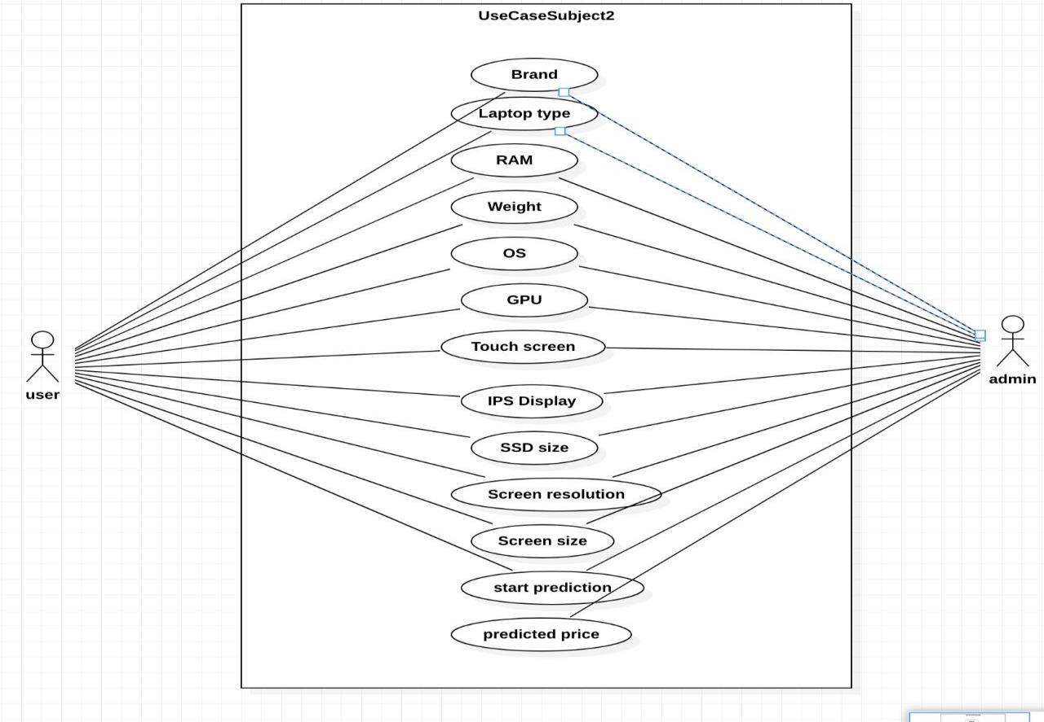
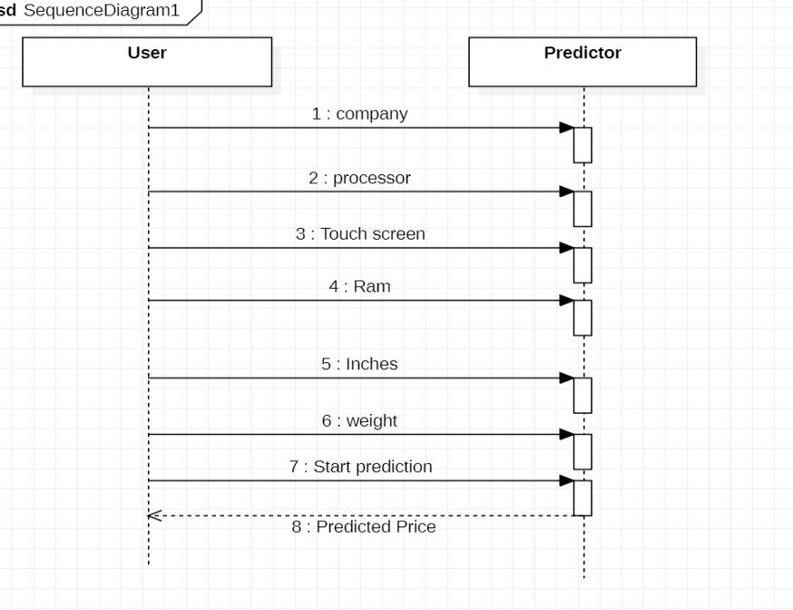
9
3.2 UML DIAGRAMS
Fig 4 Sequence Diagram
Fig 5. Use -case diagram
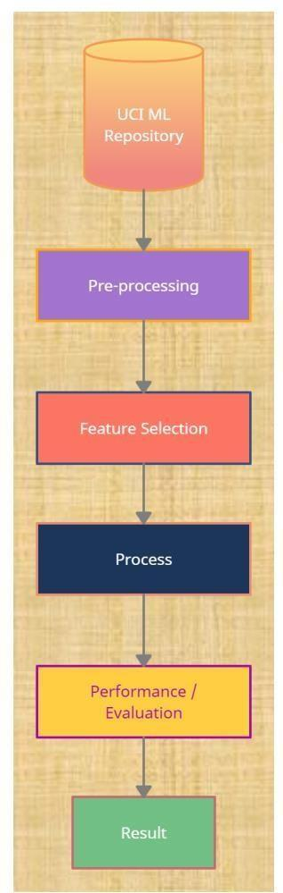
10
3.2
Flow chart
Fig 6.Flow chart
This is an analysis of laptop price prediction problems using different machine learning models. It predicts
the price of the laptop by the configurations given.
11
4
IMPLEMENTATION
4.1
MODULES
Machine learning (ML) is to help a computer learn without being explicitly instructed to do so by
means of mathematical models of data. Artificial intelligence (AI) is a subset of machine learning. Data is
analyzed using algorithms to identify patterns, which are then used to create predictive models. Like
humans, machine learning becomes more accurate with more data and experience. With machine learning,
you can adapt to situations where data is constantly changing, the nature of the requestor task is shifting, or
coding a solution isn't feasible. Three important categories of machine learning are supervised learning,
Unsupervised learning, semi-supervised learning, and reinforcement learning.
The word supervised learning comes from the word supervisor, which means teacher. In this case,
the label class will be categorized or predicted. During algorithm training, the correct answers have already
been tagged with the corresponding class labels. Support Vector Machines (SVMs), Random Forest Trees,
and Decision Trees are commonly used algorithms for supervised machine learning (Singh, Thakur, &
Sharma, 2016). Unsupervised learning occurs when input data have no class labels. In order to learn more
about the data, we want to model the data's underlying structure. There are two main types: association and
clustering. Famous un-supervised algorithms are K-means clustering, affinity propagation, etc.
4.2
Dataset
For this project, we have obtained my dataset from Kaggle. This dataset contains 1302 rows of data and
12 columns (features) that we could focus on to build our prediction model i.e., we use 12 attributes to predict
the price of the laptop.
1)
Brand:
A brand is a type of product manufactured by a particular company under a particular name. We have
different brands in laptops like Apple, HP, Lenovo, Dell, Asus, Asur, etc..in our dataset.
2)
Type of laptop:
It is a laptop type that user needs to mention in the select box given according to their wish.
3)
Ram:
RAM in GB.RAM comes shaped in physical strips. Each strip has a set amount of memory storage
space.It has values 2,4,6,8,12,16,24,32,64 .
4)
Weight:
Weight in number.
12
5)
Touch screen:
It has only two values i.e., yes(if it has a touch screen)or no(if it doesn’t have a touchscreen). Value 0:No
Value 1:Yes
6)
IPS:
IPS stands for in-plane switching, a type of LED (a form of LCD) display panel technology. IPS panels
are characterized as having the best color and viewing angles among the other main types of display panels
which, are TN (twisted nematic) and VA (vertical alignment).
Value
0:No
Value
1:Yes
7)Screen size:
Screen size in numbers(as inches)
8)
Resolution:
The numbers that we use when we talk about screen resolution are the number of pixels a screen can show
horizontally and vertically. We have values
'1920x1080','1366x768','1600x900','3840x2160','3200x1800','2880x1800','2560x1600','2560x1440','2304x144
0'.
9)
CPU: CPU stands for the central processing unit.
10)HDD:
It is in GB. A hard disk drive (HDD) is a traditional storage device that uses mechanical platters and a moving
read/write head to access data.It has values 0,128,256,512,1024,2048 GB.
11)
SSD:
It is in GB. A solid-state drive (SSD) is a new generation of storage devices used in computers. SSDs use flash-
based memory, which is much faster than a traditional mechanical hard disk. It has values 0,8,128,256,512,1024.
12)GPU:
The graphics processing unit is a specialized processor originally designed to accelerate graphics rendering.
GPUs can process many pieces of data simultaneously, making them useful for machine learning, video editing,
and gaming applications. Users need to mention the GPU brand they want in the select box.
13)
OS:
An operating system (OS) is system software that manages computer hardware, and software resources, and
provides common services for computer programs. We have different Os models like Mac and Windows. We
can choose the model we want.
13
4.3
OVERVIEW TECHNOLOGY
This section talks about the algorithms used for the project. We used four different
algorithms like Linear Regression, Random forest, K-Near Neighbor, and Decision tree.
Multiple linear regression:
Multiple linear regression (MLR), also known simply as multiple regression, is a statistical
technique that uses several explanatory variables to predict the outcome of a response variable. The goal of
multiple linear regression is to model the linear relationship between the explanatory (independent)
variables and response (dependent) variables. In essence, multiple regression is the extension of ordinary
least-squares (OLS) regression because it involves more than one explanatory variable.
Multiple linear regression analysis is carried out to predict the values of a dependent variable, Y,
given a set of p explanatory variables (x1,x2,….,XP). In these notes, the necessary theory for multiple linear
regression is presented and examples of regression analysis with census data are given to illustrate this
theory. This course on multiple linear regression analysis is therefore intended to give a practical outline to
the technique. Complicated or tedious algebra will be avoided where possible, and references will be given
to more theoretical texts on this technique. Important issues that arise when carrying out multiple linear
regression analysis are discussed in detail including model building, the underlying assumptions, and
interpretation of results. However, before we consider multiple linear regression analysis we begin with a
brief review of simple linear regression.
Formula and Calculation of Multiple Linear Regression
yi=β0+β1xi1+β2xi2+...+βpxip+ϵ
where for i=n observations:
yi=dependent variable
xi=explanatory variables
β0=y-intercept (constant term)
βp=slope coefficients for each explanatory variable
ϵ=the model’s error term (also known as the residuals)
Examples, where multiple linear regression may be used, include:
•
Trying to predict an individual’s income given several socio-economic characteristics.
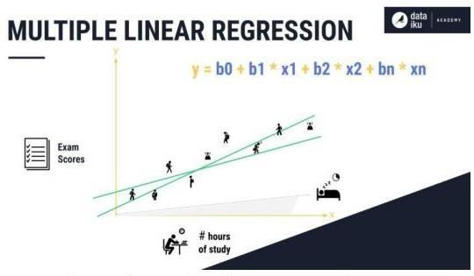
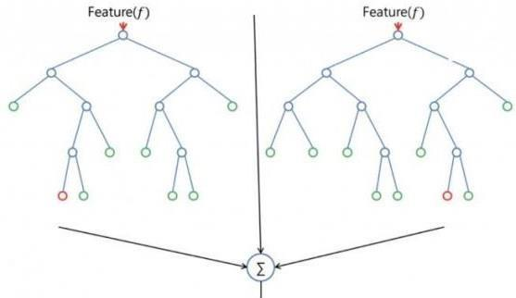
14
•
Trying to predict the overall examination performance of pupils in ‘A’ levels, given the
values of a set of exam scores at age 16.
•
Trying to estimate systolic or diastolic blood pressure, given a variety of socio-economic and
behavioral characteristics (occupation, drinking smoking, age, etc)
Fig 7. Multiple linear regression
Random forest
Random forest is used for both regression and classification-based applications. This algorithm is
flexible and easy to use. Most of the time this algorithm gives accurate results even without hyper tuning the
parameters. It builds many decision trees which on merge form a forest. While building the decision trees, adds
more randomness to the model. This algorithm searches for the best feature in the random subset of features,
which results in the formation of a better model.
Fig 8
Random forest
15
With the help of the sklearn library, we can measure the relative importance of each feature in prediction. By
finding the feature importance, we can drop the features that have less importance in the prediction process.
The main limitation of random forest is that many trees can make the algorithm too slow and ineffective for
real-time predictions. In general, these algorithms are fast to train but quite slow to create predictions once they
are trained. A more accurate prediction requires more trees, which results in a slower model. In most real-world
applications, the random forest algorithm is fast enough but there can certainly be situations where run-time
performance is important and other approaches would be preferred. With the aid of the following steps, we can
understand how the Random Forest algorithm works.
Step 1 − First, select random samples from a particular dataset.
Step 2 - Next, for each sample, this algorithm will build a decision tree. Then every decision tree will predict
the result.
Step 3 − Every predicted result will be voted in this step.
Step 4 − Finally, the final prediction result will be selected as the most voted prediction result. average pooling
we take an average of all values in a window.
Decision Tree:
Decision Tree is a Supervised learning technique that can be used for both classification and
Regression problems, but mostly it is preferred for solving Classification problems. It is a tree-structured
classifier, where internal nodes represent the features of a dataset, branches represent the decision rules and
each leaf node represents the outcome. In a Decision tree, there are two nodes, which are the Decision Node
and Leaf Node. Decision nodes are used to make any decision and have multiple branches, whereas Leaf
nodes are the output of those decisions and do not contain any further branches.
The decisions or the test are performed on the basis of features of the given dataset. It is a graphical
representation for getting all the possible solutions to a problem/decision based on given conditions. It is called
a decision tree because similar to a tree, it starts with the root node, which expands on further branches and
constructs a tree-like structure. In order to build a tree, we use the CART algorithm, which stands for
Classification and Regression Tree algorithm. A decision tree simply asks a question and based on the answer
(Yes/No), it further split the tree into subtrees.
Decision tree methodology is a commonly used data mining method for establishing classification systems
based on multiple covariates or for developing prediction algorithms for a target variable. This method
classifies a population into branch-like segments that construct an inverted tree with a root node, internal nodes,
and leaf nodes. The algorithm is nonparametric and can efficiently deal with large, complicated datasets without
imposing a complicated parametric structure. When the sample size is large enough, study data can be divided
into training and validation datasets.
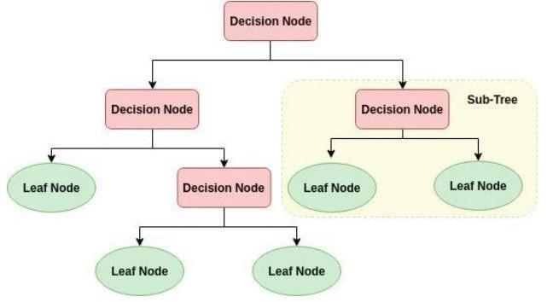
16
This paper introduces frequently used algorithms used to develop decision trees (including CART, C4.5,
CHAID, and QUEST) and describes the SPSS and SAS programs that can be used to visualize tree structure.
Step-1: Begin the tree with the root node, says S, which contains the complete dataset.
Step-2: Find the best attribute in the dataset using the Attribute Selection Measure (ASM).
Step-3: Divide the S into subsets that contain possible values for the best attributes.
Step-4: Generate the decision tree node, which contains the best attribute.
Step-5: Recursively make new decision trees using the subsets of the dataset created in step -3. Continue this
process until a stage is reached where you cannot further classify the nodes and called the final node as a leaf
node.
Fig 9 Decision Tree
K-nearest neighbour (KNN):
The k-nearest neighbor technique is a machine learning algorithm that is considered simple to
implement (Aha et al. 1991). The prediction problem can be mapped into a similarity-based
classification. The historical data and the test data are mapped into a set of vectors. Each vector
represents an N dimension for each feature. Then, a similarity metric such as Euclidean distance is
computed to take a decision. In this section, a description of KNN is provided. KNN is considered
lazy learning that does not build a model or function previously but yields the closest k records of the
training data set that have the highest similarity to the test. Then, a majority vote is performed among
the selected k records to determine the class label and then assigned it to the query record.
The prediction of price is computed using KNN as follows:
a)
Determine the number of nearest neighbors, k.
b)
Compute the distance between the training samples and the query record.
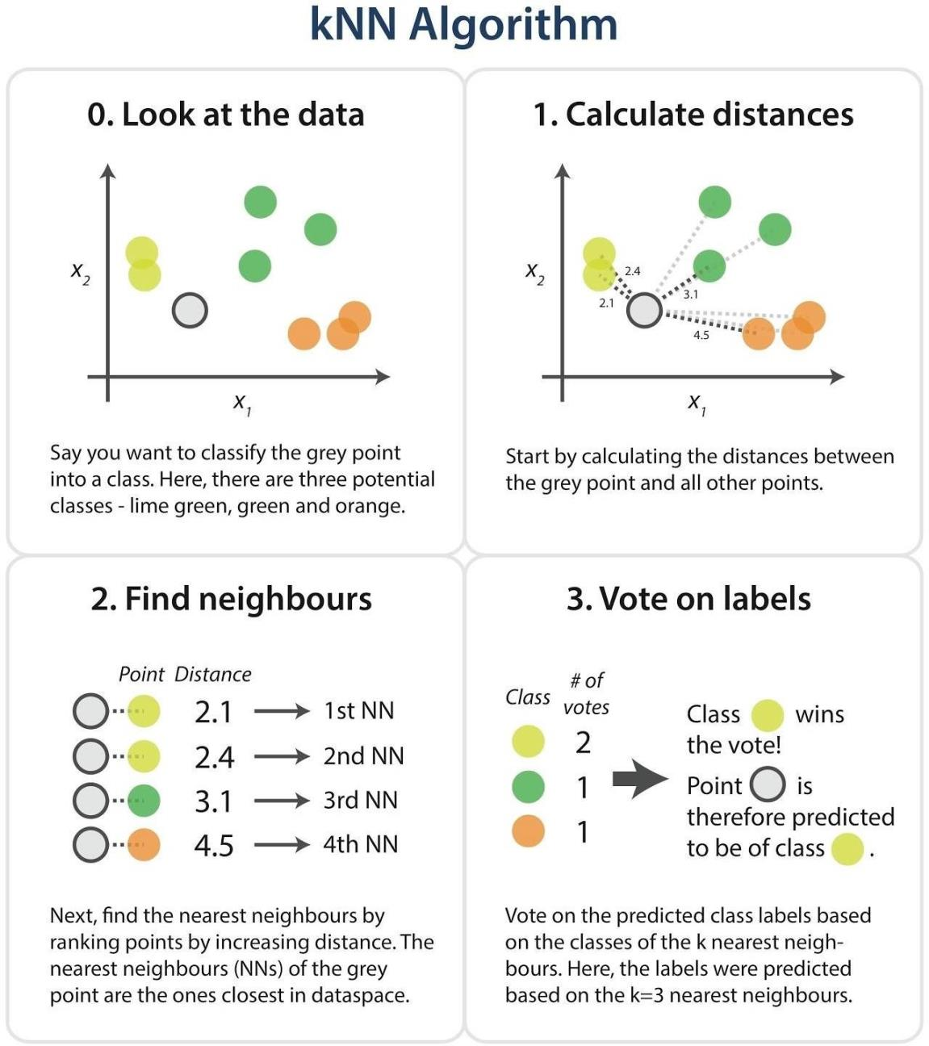
17
c)
Sort all training records according to the distance values.
d)
Use a majority vote for the class labels of k nearest neighbours, and assign it as a prediction value
of the query record.
Fig 10 KNN Algorithm

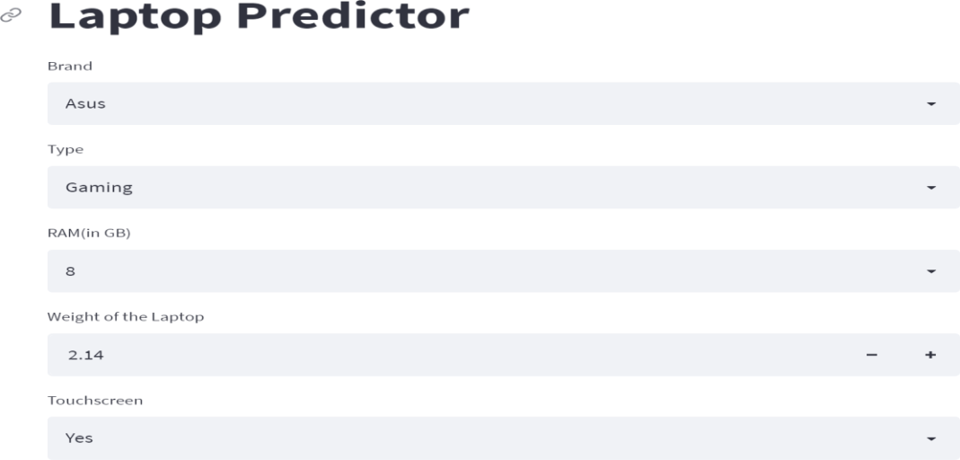
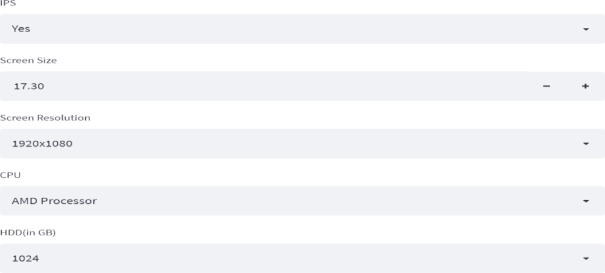
18
5.
TESTING
5.1
TEST CASES
1)
User will fill in specifications with his desired configurations and gets the predicted price.
2)
If we keep zero to any specifications like weight, and screen size it leads to error. Every specification
must be filled. Don’t leave any specifications.
5.2
TEST RESULTS
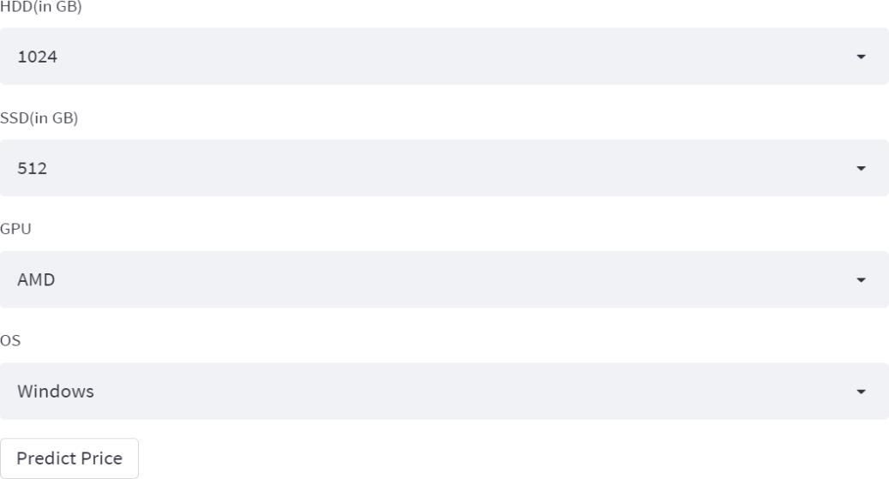
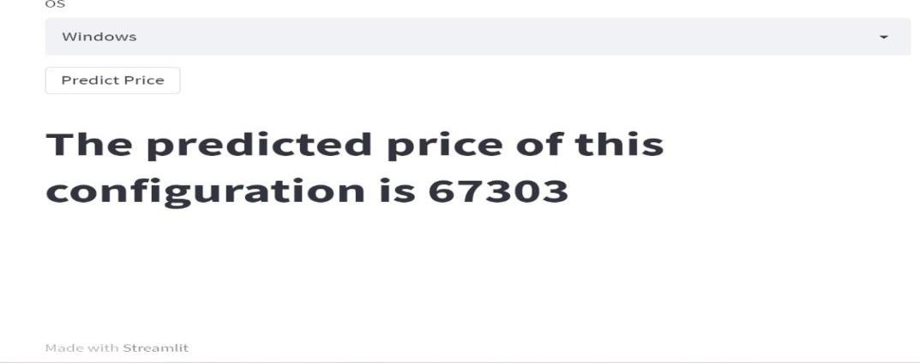
19
Fig 11 Test result
Figure 11 represents the result of the test case in that user will get the predicted price by filling in all the
specifications. The predicted price of this configuration is 67303.
Figure 12 represents the result of the test case in that user will get an error because of not filling total
specifications and keeping zero in screen size.
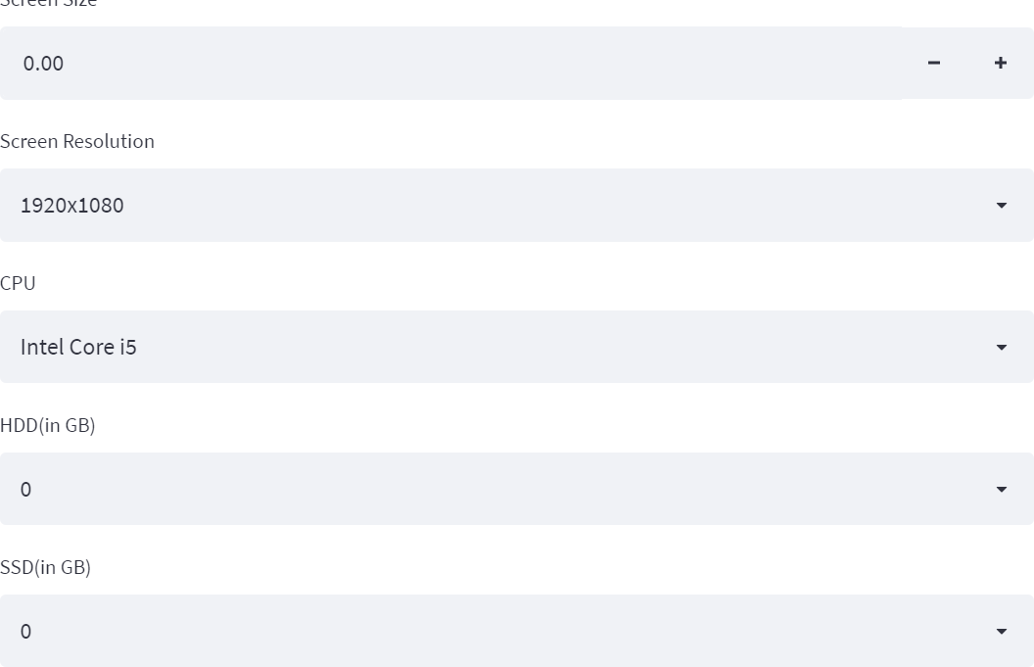
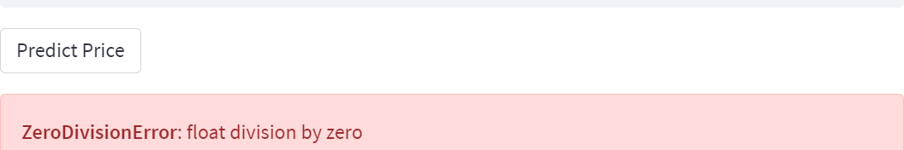
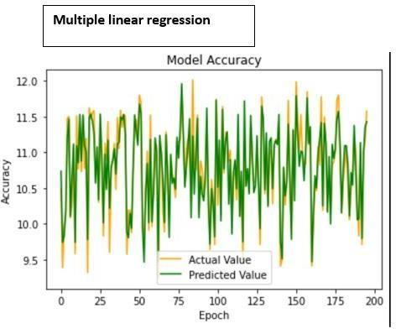
20
6.
RESULTS
Fig 12 Test result
Fig 13 Accuracy of multiple linear regression algorithm
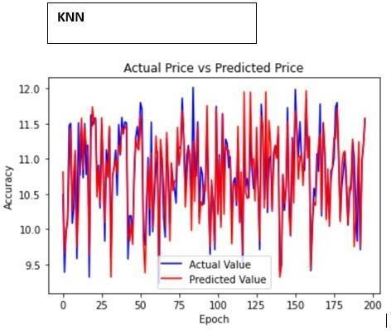
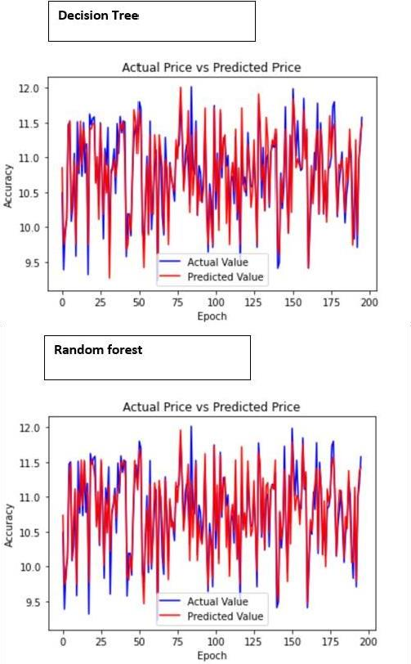
21
Fig 14 Accuracy of the KNN algorithm
Fig 15 Accuracy of decision tree and random forest algorithms
22
The above figures represent the “Epoch vs Accuracy graph” which refers to the Model Accuracy of all the four
different models that were implemented. We predict from test data; the following were the predictions made
from four different models that were implemented.
Result of various models with the proposed model
Algorithm
Accuracy rate
Multiple Linear regression
80.73%
Random forest
88.75%
Decision tree
84.69%
KNN
80.21%
Price
Prediction
using
Accuracy
Mean absolute error
Multiple
Linear
Regression
0.8073277448418645
0.21017827976428802
Random forest
0.8875301429227068
0.15875464162243105
Decision tree
0.8469387025658242
0.18222142011995746
KNN
0.8021984604448553
0.19319716721521116
The algorithms that we used Multiple linear regression, random forest, KNN, and decision tree. As
we can see from the above table, we compared the accuracy rates of four different models. When we
compared these algorithms the accuracy rate for the Random forest is more than the other three algorithms.
The above table shows the accuracy rates of the algorithms and also the mean absolute errors of the
algorithms, whereas random forest is 88.75%, linear regression is 80.65%, KNN is 80.21% and the decision
tree is 84.05%.
23
7.
CONCLUSION.
We created a website that Predicts the prices of laptops using the user’s desired configurations
and using laptop price predictors and gaining knowledge of using the Decision Tree algorithm makes it easy
for students, in particular in deciding the choice of laptop computer specifications that are most ideal for
students to meet pupil desires and by the buying energy of students. Students no longer want to appear for
various sources to discover laptop specs that are needed by college students in assembly the wishes of students
because the laptop computer specifications from the results of the computer gaining knowledge of application
have furnished the most perfect specs with the prices of their laptops.
8.
FUTURE SCOPE
Our project is new in innovation in the market, it gives benefits to the users in finding the prices of
laptops.
In the future, this machine learning model may bind with various websites that can provide real-
time data for price prediction. Also, we may add large historical data on laptop prices which can help to
improve the accuracy of the machine learning model. We can build an android app as a user interface for
interacting with users. For better performance, we plan to judiciously design deep learning network
structures, use adaptive learning rates, and train on clusters of data rather than the whole data set.
9.
BIBLIOGRAPHY
[1].Analyzing House Price Variations. IBIMA Publishing Communications of the IBIMA Vol. 2012 (2012),
Article ID 383101, 9 pages DOI: 10.5171/2012.383101.
[2]. Babyak, M. A. What you see may not be what you get: A brief, nontechnical introduction to overfitting
regression-type models. Psychosomatic Medicine, 66(3), 411-421.
[3]. Atharva shoogles, Priyanka chair, Akshata gaud, Jinal Jain.House Price Forecasting using Data Mining
Techniques International Journal of Advanced Research in Computer and Communication Engineering ISO
3297:2007 Certified Vol. 6, Issue 12, December 2017
[4]. Darshan Sanghani, Kelby Erickson, and Mohammad Al Hasan Predicting Zillow Estimation Error Using
Linear Regression and Gradient Boosting, IEEE 14th International Conference on MobilAd Hoc and Sensor
Systems (MASS), Page(s):530 - 534.
[5]. Model, Azmi Bin Khamis, Nur Khalidah Khalilah Binti Kamarudin, Comparative Study On Estimate
House Price Using Statistical And Neural Network, International journal of scientific and technology, research
24
volume 3, ISSUE 12, December 2014,Page(s):126-131.
[6]. Adyan Nur Alfiyatin, Hilman Taufiq, Ruth Ema Febrita, Wayan Firdaus Mahmudy,Modeling House Price
Prediction using Regression Analysis and Particle Swarm Optimization Case Study: Malang, East Java,
Indonesia. (ITASCA) International Journal of Advanced Computer Science and Applications, Vol. 8, No. 10,
2017, Page(s):323-326..
[7]
S. Jyothirmayee, V. D. Kumar, C. S. Rao, and R. S. Shankar, “Predicting Stock Exchange using Supervised
Learning Algorithms,” no. 1, pp. 4081-4090, DOI: 10.35940/invitee.A4144.119119.
[8]
H. Snyder, “Literature review as a research methodology: An overview and guidelines,” J. Bus. Res., vol.
104, no. 2019, pp. 333-339, DOI: 10.1016/j.jbusres.2019.07.039.
[9]
N. S. Selamat, “An Overview of Big Data Usage in Disaster Management,” vol. 11, no. 1, pp. 35-40.
[10]
R. P. Schumaker and H. Chen, “Textual Analysis of Stock Market Prediction Using Breaking Financial
News: The AZFinText System,” no. 2006, pp. 1 -29.

